Christian Family Services
Current-State IT Architecture Review
  - Prepared from on-site photos, Fing discovery results, Windows screenshots, and manual notes
13 March 2026

Executive summary
The CFS environment appears to have grown in layers over time. The most critical asset is likely the Dell PowerEdge R720, which appears to host multiple VMware virtual machines that support directory, file, print, and administration functions. The biggest immediate technical concern is the amber fault indication on Drive 0 of the R720, which may indicate a degraded or at-risk RAID set. The network stack also looks more complex than necessary, with Spectrum equipment, a Cisco ASA 5506-X, a MikroTik RB3011, and an older Netgear FS728TP switch all present in the path. The Netgear switch is managed-capable but is primarily a 10/100 Fast Ethernet PoE switch, which is a likely performance and lifecycle concern. Based on the evidence gathered so far, CFS should first stabilize and verify server health and backups, then identify the true default gateway and current switch configuration before simplifying the edge stack.

Key findings
- The live CFS LAN uses subnet 192.168.44.0/24 with default gateway 192.168.44.1, DNS server 192.168.44.100, and SSID “CFS”.
- Fing identified 35 active devices during the scan.
- Observed core infrastructure includes: Hitron EN2251 modem, Spectrum router/gateway, Cisco ASA 5506-X, MikroTik RB3011UiAS-RM, Netgear FS728TP switch, Panduit patch panels, TP-Link access point, and Dell PowerEdge R720 server.
- Fing identified active VMware virtual machines: VJUMP (.30), CFSDC2 (.60), CFSFS (.61), and CFSPRN (.62).
- The Dell PowerEdge R720 shows an amber/yellow indicator on Drive 0 and reportedly beeps occasionally, suggesting a storage or RAID alert that should be investigated promptly.
- The Cisco ASA 5506-X and MikroTik RB3011 may be duplicating network-edge or routing functions, but their exact roles are not yet fully confirmed.
- The Netgear FS728TP is a managed-capable older Fast Ethernet PoE smart switch and is a strong candidate for replacement after configuration review.

Inferred wiring / connectivity diagram
This diagram is the best current interpretation of Ethernet connectivity from the observed cabling, device labels, screenshots, and Fing discovery. Items shaded amber/red indicate uncertainty or review points.
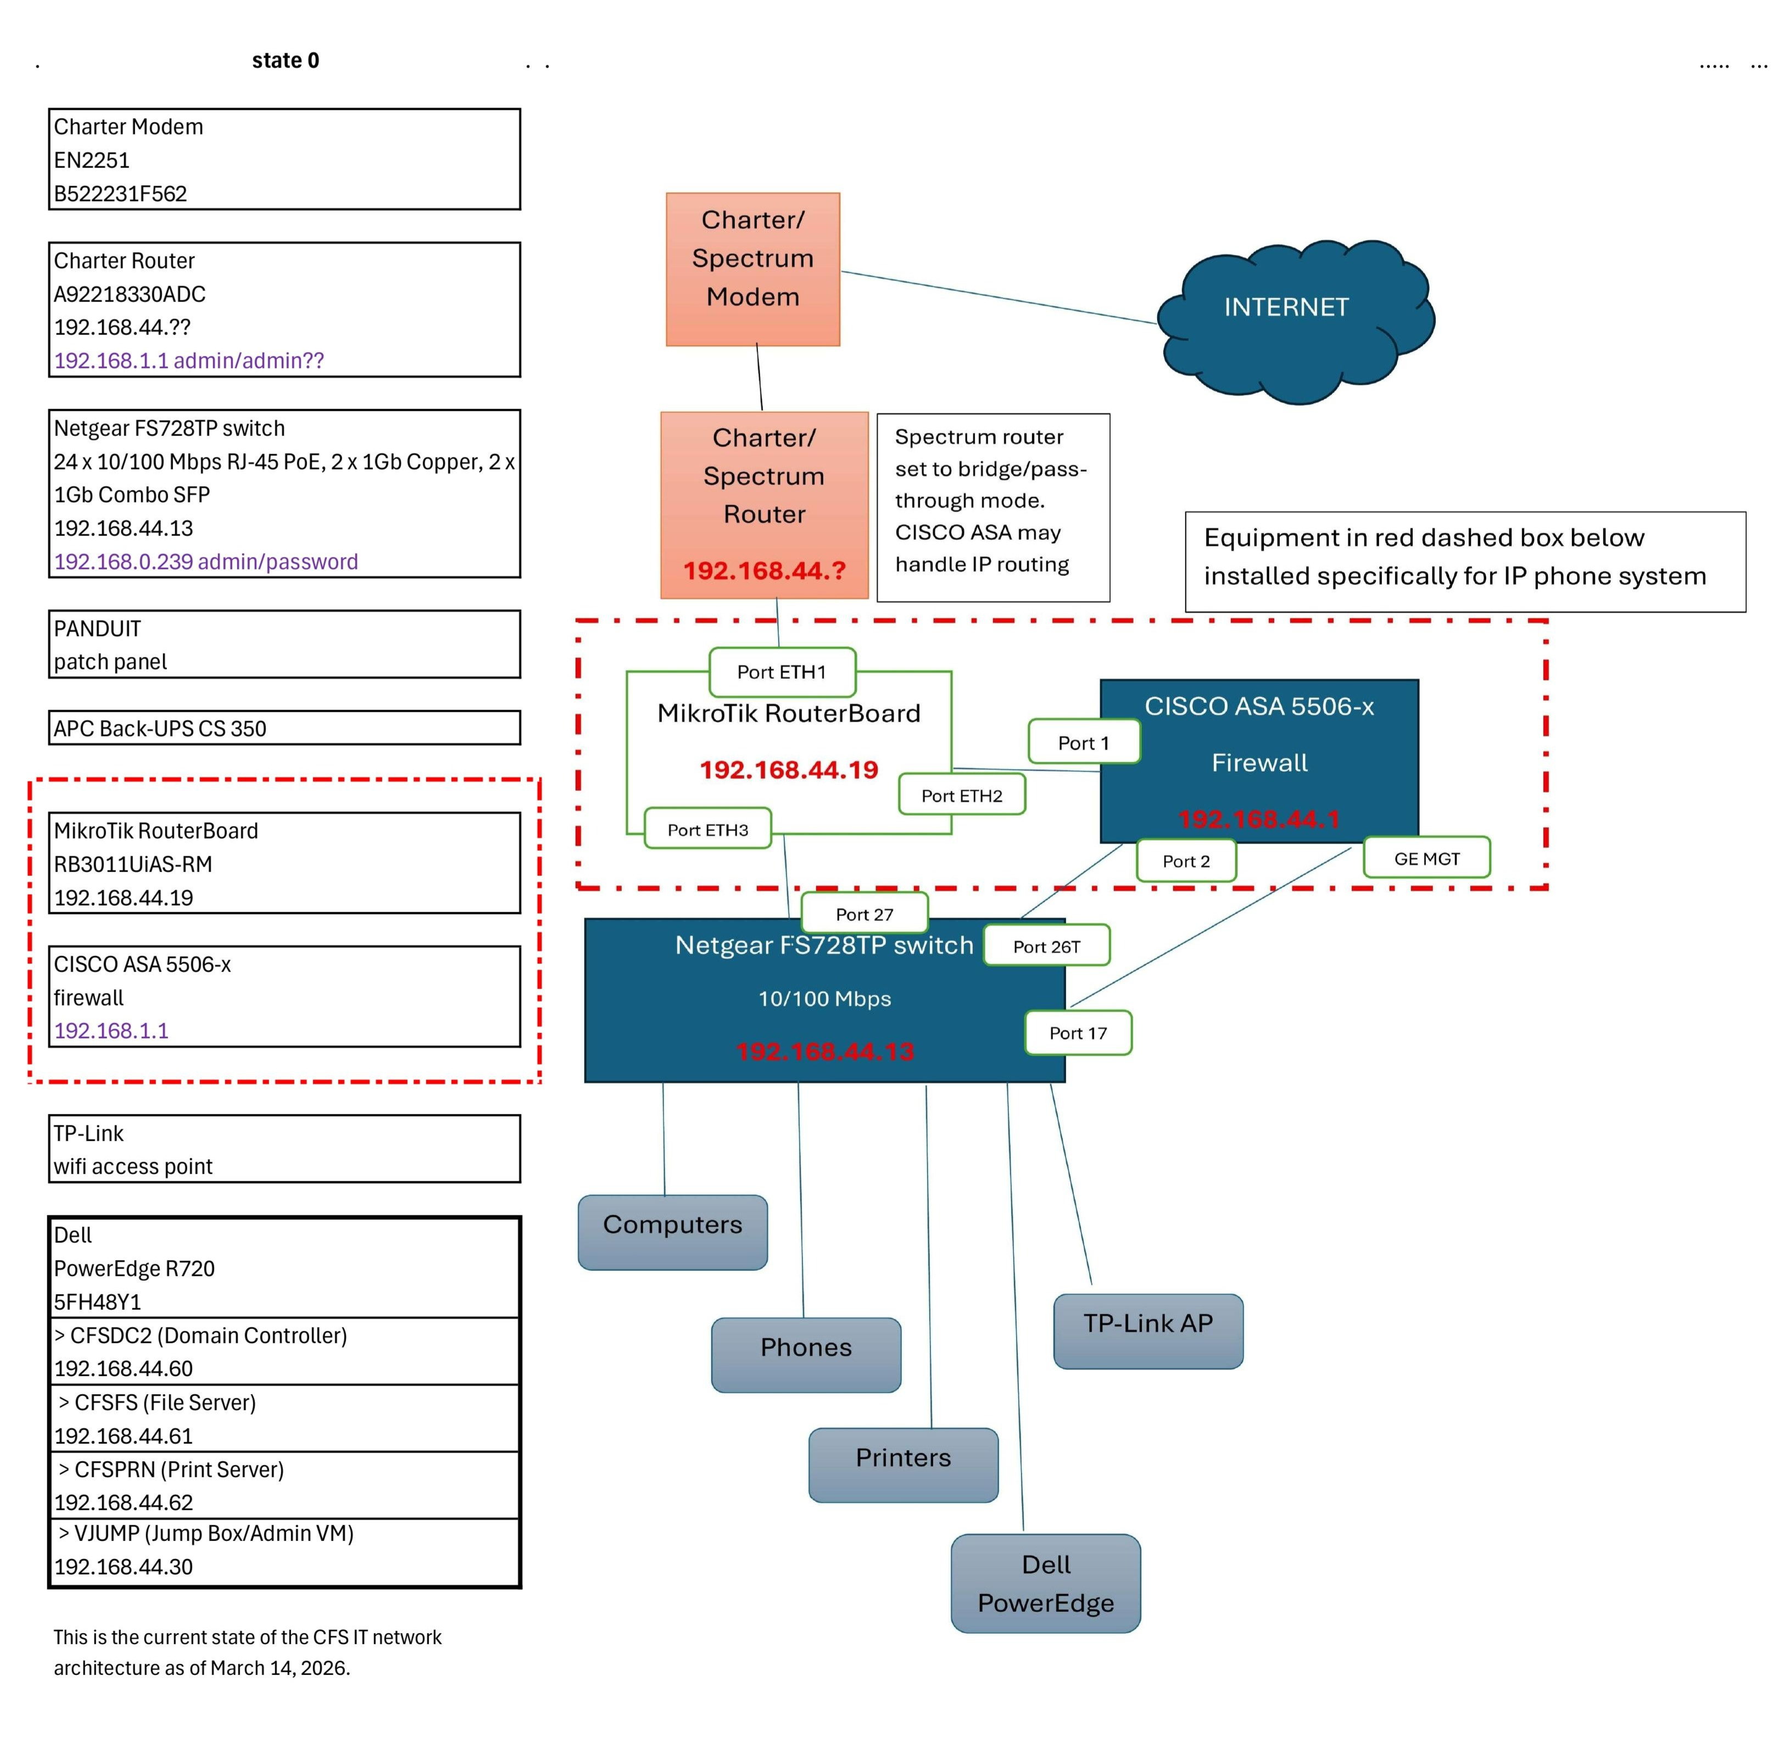
Figure 1. Inferred current-state wiring diagram for the CFS network.

Network overview
Item | Observed value
SSID | CFS
Provider | Spectrum Business
Observed public IP | 96.35.181.122
Subnet | 192.168.44.0/24
Default gateway | 192.168.44.1 (device not yet conclusively identified)
DNS server | 192.168.44.100
Observed DNS suffix / internal namespace | cfamily.local
Observed device count | 35 online devices

Observed device list from Fing
The following list highlights the most important devices positively identified in Fing. Many additional “Generic” devices were present and should be classified later.
IP | Name | Type | Brand | Model | OS
192.168.44.15 |  | Printer | HP
192.168.44.18 | CFSDT-01 | Computer | Dell |  | Android
192.168.44.88 | CFSDT-04 | Computer | ASRock |  | Windows
192.168.44.30 | VJUMP | Virtual Machine | VMware | Virtual Machine
192.168.44.62 | CFSPRN | Virtual Machine | VMware | Virtual Machine
192.168.44.60 | CFSDC2 | Virtual Machine | VMware | Virtual Machine
192.168.44.77 | CFSDT-02 | Computer | Dell |  | Windows
192.168.44.19 | Christian Family Service MTik | Router | MikroTik | RB3011UiAS-RM
192.168.44.70 |  | Laptop | Apple |  | macOS
192.168.44.61 | CFSFS | Virtual Machine | VMware | Virtual Machine
192.168.44.86 | CFSLT-08 | Computer |  |  | Windows
192.168.44.150 | KM486A09 | Printer | Konica Minolta | bizhub C361i
192.168.44.13 |  | Switch | Netgear | ProSAFE 24 Port 10/100 PoE Smart Switch
192.168.44.11 | iPhone | Mobile | Apple | iPhone 13 | iOS

Detailed device inventory and assessment
The table below combines observed evidence, inferred purpose, approximate platform age, known issues, and recommended next actions. Age estimates are approximate platform-era estimates, not guaranteed purchase dates.
Device | Purpose / role | IP / identifier | Approx. age | Observed issues | Recommended action
Hitron EN2251 cable modem | ISP handoff / cable modem | n/a observed | Likely ISP-supplied; exact deployment age unknown | No specific fault observed | Keep unless ISP changes service
Spectrum router / Wi‑Fi gateway | Possible edge router, NAT device, and/or wireless gateway | n/a observed | Unknown | Role overlaps with ASA/MikroTik possible; exact active function not yet confirmed | Verify current role; possible simplification candidate
Cisco ASA 5506-X | Firewall / security appliance / possible VPN endpoint | not identified in scan | ~2015 platform era | Older platform; role not fully confirmed; near/at end of useful support life | Verify whether still required; likely removal candidate if redundant
MikroTik RB3011UiAS-RM | Router / routing appliance | 192.168.44.19 | mid-2010s platform era | Active on LAN; exact routing / DHCP / VLAN role not fully confirmed | Review config before considering removal or replacement
Netgear FS728TP | Main rack switch; managed-capable smart PoE switch | 192.168.44.13 | late-2000s platform era | Primarily 10/100 Fast Ethernet access switch; possible performance bottleneck; managed config unknown | Export / review config; strong replacement candidate
Panduit patch panels & cable management | Passive cabling termination and cross-connect | n/a | age unknown | No issue observed; labeling appears limited | Retain; improve labeling and documentation
TP-Link access point | Wireless access point for office Wi‑Fi | not identified in scan by model | age/model unknown | Exact model and management method unknown | Confirm model, power method, and controller/standalone status
Dell PowerEdge R720 | Primary on-prem server; likely VMware host | host IP not yet confirmed | 2012–2013 platform era | Drive 0 amber/yellow; occasional beeping reported; likely storage / RAID alert | Urgent: check RAID/PERC/iDRAC status and backups; medium-term replacement target
VMware VM: VJUMP | Likely jump/admin VM | 192.168.44.30 | unknown | Purpose inferred from name only | Confirm role, OS, owner, and backup
VMware VM: CFSDC2 | Likely domain controller | 192.168.44.60 | unknown | Critical if serving directory/authentication | Confirm role, OS, owner, and backup
VMware VM: CFSFS | Likely file server | 192.168.44.61 | unknown | Critical if serving shared files | Confirm role, storage mapping, and backup
VMware VM: CFSPRN | Likely print server | 192.168.44.62 | unknown | Shared printing dependency likely | Confirm role and printer dependencies
HP printer | Shared network printer | 192.168.44.15 | unknown | No issue observed | Retain / document model and location
Konica Minolta bizhub C361i | Shared multifunction printer/copier | 192.168.44.150 | unknown | No issue observed | Retain / document support contact and usage
CFSDT-02 | User workstation (Dell / Windows) | 192.168.44.77 | unknown | Observed on CFS domain-like network | Document owner and business function
CFSDT-04 | User workstation (ASRock / Windows) | 192.168.44.88 | unknown | Observed on CFS domain-like network | Document owner and business function

Key risks and issues
- Possible degraded RAID or drive failure on the Dell PowerEdge R720 (Drive 0 amber, server beeping).
- Aging server platform likely hosting multiple critical VMs.
- Unclear ownership of the actual default gateway at 192.168.44.1.
- Potential overlap or unnecessary complexity across Spectrum gateway, Cisco ASA, and MikroTik router.
- Netgear FS728TP switch is an older managed Fast Ethernet platform and may constrain performance.
- Unknown current switch configuration (VLANs, PoE dependencies, management settings, uplink use).
- Unknown current backup posture for VMware host and guest VMs.

Simplification opportunities
- Move toward a simpler edge design: ISP modem → single modern firewall/router → single modern managed gigabit/PoE switch.
- Replace the Netgear FS728TP with a modern managed gigabit PoE switch after the current configuration is reviewed and documented.
- Retire the Cisco ASA 5506-X if it is no longer providing a unique security or VPN function.
- Retire or replace the MikroTik RB3011 only after confirming whether it handles routing, DHCP, VLANs, or inter-VLAN traffic that must be preserved.
- Plan medium-term migration away from the Dell PowerEdge R720 to newer host hardware or a cloud / managed alternative, depending on business requirements.

Recommended next steps
1. Immediately check the Dell PERC/RAID status, iDRAC logs, and backup status before any drive is removed or replaced.
2. Identify which device actually owns 192.168.44.1 (the true default gateway).
3. Export or inspect the Netgear FS728TP configuration to determine whether VLANs, PoE, management ACLs, or other features are in use.
4. Document the exact role of the Cisco ASA 5506-X and the MikroTik RB3011.
5. Confirm the VMware host, the purpose of each VM, and recovery / restore capability.
6. Label patch-panel ports, switch uplinks, and critical cable runs to improve supportability.
7. After the above is complete, design a simplified future-state network and migration plan.

Assumptions and caveats
- This document reflects observed evidence from the site visit and device discovery on 13 March 2026; some roles remain inferred rather than confirmed.
- Exact purchase dates, support contracts, and software versions were not fully available.
- Device purpose for several VMware guests is inferred primarily from hostnames and should be validated with administrative access.
- The wiring diagram is an inferred current-state map, not a certified as-built drawing.

